COURSE CODE: PRAC101 Section: BSIT - 4103

COURSE TITLE: OJT / PRACTICUM 1

TERM: 1st Semester, SY 2025-2026

PROFESSOR: MR. VINCENT CARLO T. GARADOS

NAME OF STUDENT: MAHUSAY, CHRISTIAN B.

**OJT NARRATIVE REPORT**

1. TOPIC: PLENARY ORIENTATION
2. SPEAKER: MR. MARC TONIDO
3. DURATION: 2:15 PM – 3:45 PM
4. SCREENSHOT OF DUTY

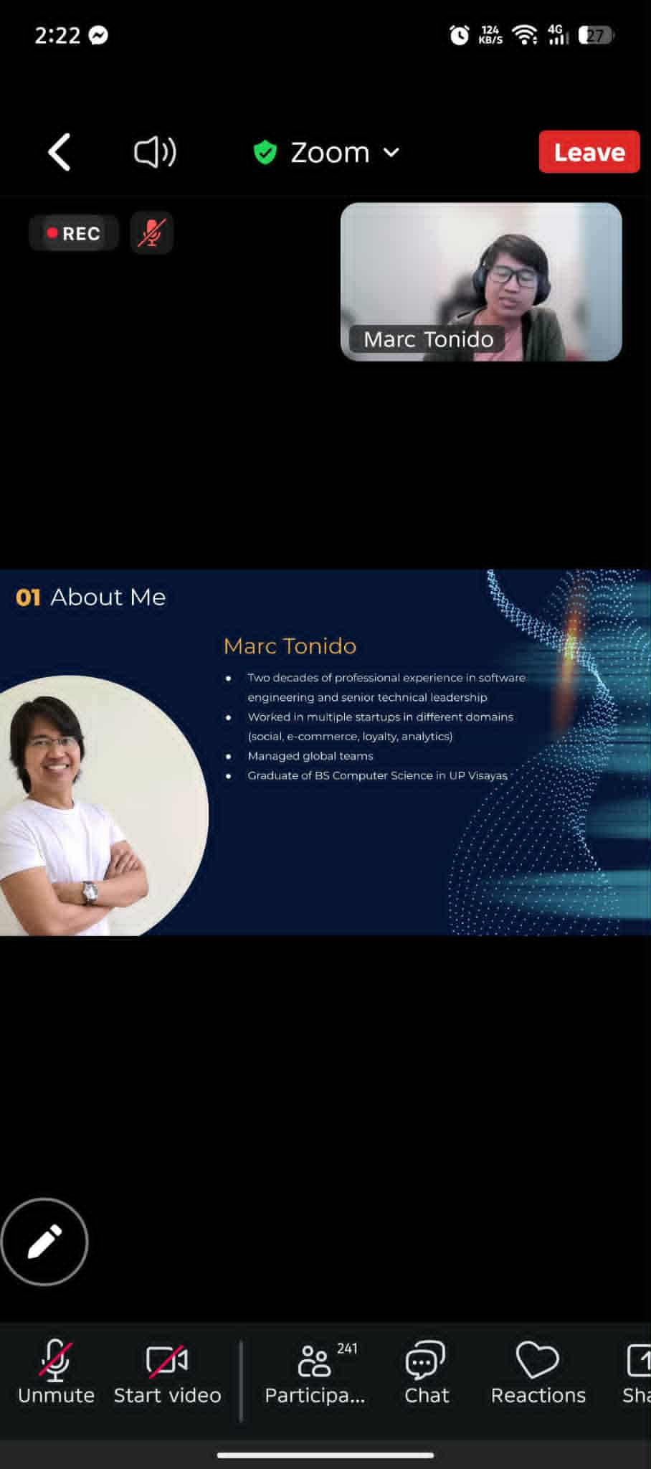

1. REFLECTION

PLENARY ORIENTATION

The plenary orientation introduced the overall structure of the program, covering topics from AI fundamentals and trends to cybersecurity, cloud security, and web application security. It was helpful to see the full schedule of sessions and the clear guidelines for participation, such as punctuality, proper device setup, and maintaining a professional environment.

I also appreciated learning about the facilitator’s background in software engineering and leadership, which gave credibility and context to the sessions. Overall, the orientation gave me a clear roadmap of what to expect and how to prepare, setting a positive and organized tone for the rest of the program.